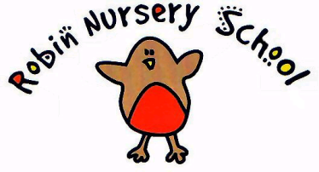
POLICY FOR LATE PAYMENT OF FEES

Statement of Intent
Robin Nursery School will state the terms of payment with the parents on registration of the child. Full details will be available for reference in the prospectus.

The nursery has to ensure that children do not suffer as a result of such a dispute and that their education is not disrupted. Therefore the Nursery has evolved this policy of handling such situations.

The Nursery is committed to support parents who may encounter unexpected financial difficulties by allowing them to pay on a weekly basis in the short term. However the nursery reserves the right to discontinue providing care for a child where the payment of fees falls into arrears. Regular late payment of fees will be deemed as a breach of contract and the nursery place will be terminated. The nursery will endeavor to collect outstanding fees once a child has left.

Procedure
At the beginning of every half term an invoice will be given to the parent/carer for the following half term. On that invoice it will give a date for fees to be paid. Fees can be paid to the Nursery by cash, cheque, bank transfer or, by prior arrangement, Childcare Vouchers. If the payment date is not adhered to Robin Nursery School will use the following procedure

- 1 week after the deadline date a yellow invoice will be issued as a polite reminder

- 2 weeks after the deadline date a red invoice will be issued with a 10% increase of fees

- If after 3 weeks the invoice has not been honored and no payment plan has been arranged it will be to the sole discretion of the Robin Nursery School Committee. In extreme cases of non payment the child’s place will be at risk

This policy was adopted at a meeting of The Robin Nursery Committee 14/11/13

Signed on behalf of the Nursery ________________ Position ______________

Date for review 14/11/14

