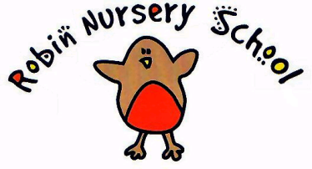
SUPERVISION OF STAFF POLICY

Statement of Intent
Supervision provides a framework to provide direction and guidance to individual staff members on a regular basis. Effective supervision provides support, coaching and training for each practitioner and promotes the welfare of each child. Our supervision framework fosters a culture of mutual support, teamwork and continuous improvement that encourages the confidential discussion of sensitive issues.

Aim
Through regular supervision meetings, staff will have the opportunity to:
- Ensure that the provision promotes the interest of children at all times.
- Be supported in managing the demands of the job.
- Be supported in their professional development.
- Have the opportunity to reflect on their practice and receive constructive feedback in a safe and appropriate manner.
Format of Supervision Meetings
Supervision meetings will take place at least once a term and will be conducted one-to-one in a confidential environment. All supervision meetings will be carried out by the manager. The manager’s supervision will be carried out by the committee chairperson. Meetings will last no longer than 1 hour.
Supervision meetings should be a two-way process, where both the supervisee and the supervisor have the opportunity to raise items for discussion. Notice of the meeting will be given to allow for the preparation of issues or concerns to be discussed.
Details of supervision meetings will be recorded on a ‘supervision meeting record’ sheet. A signed copy should be kept by the practitioner and the original copy kept securely in the setting’s ‘Staff Supervision’ file. The record should either be hand written at the time of the meeting or typed up soon after the meeting.

Legal Framework
Working Together to Safeguard Children. (revised 2010)
Statutory Framework for the Early Years Foundation Stage 2012

This policy was adopted at a meeting of The Robin Nursery Committee on 14/11/13

Signed on behalf of the Nursery _______________ Position ________________

