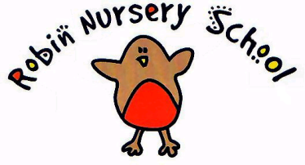
ANIMALS IN THE SETTING POLICY

Statement of intent

Children learn about the natural world, its animals and other living creatures, as part of the Learning and Development Requirements of the Early Years Foundation Stage. This may include contact with animals, or other living creatures, either in the setting or on visits. We aim to ensure that this is in accordance with sensible hygiene and safety controls.
Procedures
Animals visiting Robin Nursery
- we carry out a risk assessment with a knowledgeable person accounting for any hygiene or safety risks posed by the animal or creature
- we provide suitable housing for the animal or creature and ensure this is cleaned out regularly and is kept safely
- we ensure that water and the correct food is offered, at the right times
- children are taught correct handling and care of the animal or creature and are supervised
- Children wash their hands after handling the animal or creature and do not have contact with animal soil or soiled bedding.
- staff wear disposable gloves when cleaning housing or handling soiled bedding
- if animals or creatures are brought in by visitors to show the children, they are the responsibility of their owner
- the owner carries out a risk assessment, detailing how the animal or creature is to be handled and how any safety or hygiene issues will be addressed.

Visits to farms:
- before a visit to a farm, a risk assessment is carried out - this may take account of safety factors listed in the farm’s own risk assessment, which should be viewed
- the outings procedure is followed
- children wash their hands after contact with animals
- outdoor footwear worn to visit farms is cleaned of mud and debris and should not be worn indoors.

Legal framework
- The Management of Health and Safety at Work Regulations (1999)
Further guidance
Health and Safety Regulation…A Short Guide (HSE 2003)
This Policy was adopted at a meeting of the Robin Nursery Committee
Reviewed and updated on 28th October 2020
Signed on behalf of Robin Nursery: Teresa Cutler (Manager)
Signed on behalf of Committee: Jane Follett (Chair)

Signed on behalf of the Management Committee:

