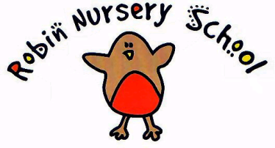
Recruitment policy
Our nursery management committee and staff are committed to non discriminatory recruitment and retention practices which follow current legislation.
We work towards an equal opportunities policy, seeking to offer job opportunities equally to both women and men, with and without disabilities, from all religious, social, ethnic and cultural groups. There will be no age discrimination. We are committed to recruiting, appointing and employing staff in accordance with all relevant legislation. We will try to employ the most suitable person for any vacancy that arises.
By adopting this process we believe that the nursery will
- Decrease staff turnover and eliminate costs incurred with recruiting new staff
- Recruit suitable staff who have a clear idea of what to expect and who know what they are doing
- Increase employee motivation and productivity
- Decrease staff absence
Methods
The Robin Nursery School recruitment procedure will have the following elements
- A Job description
- A person Specification
- A Job advert
- Selection of candidates – interview/assessment
- Appointment of candidate
- Induction programme
New staff are recruited through adverts. Advertisements for the job are placed on the nursery notice board, in local notice boards, in our village magazine, and if considered necessary, in the Job Centre and local newspapers. Location, hours, and job description / person specification are included in the advert.
All shortlisted applicants are invited to complete a shadow session at The Robin Nursery and attend an interview panel consisting of at least one senior staff and one member of the management committee.
CRB checks and references will always be sorted before a prospective employee is left in a position of responsibility. New employees are provided with job descriptions, confidentiality agreements and contracts that reflect the current nature of the post. All new positions are subject to a three months probationary period. Unsuccessful applicants are informed by the committee's secretary, explanations for non employment will be given only if requested.
We have an induction procedure for new staff which includes going through a checklist, policies, procedures and contracts prior to starting date and we operate a mentoring system. A monthly appraisal is carried out throughout the probationary period, with any training / supervision requirements addressed at this stage.
All staff should be aware of our Disciplinary / Grievance Policy.
We will continue to keep abreast of changes to recruitment legislation sourcing advice from relevant agencies.

This policy was adopted at a meeting of The Robin Nursery Committee

Held on ………………………………

Date to be reviewed ……………………………

Signed on behalf of the Nursery ………………………………………

Name of signatory …………………………………………….. (Chairperson)

