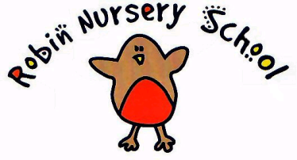
NAPPY CHANGING POLICY

Statement of intent

We wish to include all children in our setting and understand that children arrive at nursery at different stages in their development and that some children may still be in nappies or trainer pants. We work with parents towards toilet training, unless there are any medical or developmental reasons why this would be inappropriate at that time.

We provide nappy changing facilities and exercise good hygiene practices in order to accommodate children who are not yet toilet trained.

Procedures

In the event of it being necessary to change a child’s nappy, or carry out any other form of intimate care ie changing wet or soiled clothes, the following procedures will be followed.

1. In order to care for the children’s physical needs we ask that parents/carers:

- Make sure that wherever possible children arrive at nursery wearing a clean nappy or trainer pants
- Provide nappies, cream(if needed), wipes and bags for soiled nappies so that if it is necessary to change the child their individual needs can be met (Creams must be recorded in the ‘medication’ book)
- Provide a change of clothes in case of wetting or soiling accidents (although the nursery does have spares, many children prefer their own familiar clothes)
- Discuss any issues arising from the policy with the child’s key worker

2. The Nursery will ensure that:

- Nappy changing and other intimate care (ie changing wet/soiled clothes, assisting children on the potty etc) will be carried out ONLY in the designated area (disabled toilet). The door must remain open with the adult facing out of the room, so as to preserve the child’s dignity when lying on the changing mat, and ensure that the adult works in an overt and observable way.
- Only a person with a clear and current DBS check will change children’s nappies or trainer pants or carry out any form of intimate care.
- The designated area/mats etc. will be cleaned before and after a child is changed with a suitable disinfectant cleaner
- Staff will wear clean disposable gloves for each child (gloves and plastic aprons will be provided by the nursery)
- Appropriate hand washing facilities will be available for the adult and the child and hands will be washed using soap and dried thoroughly with a paper towel after completing the procedure
- Soiled or wet nappies will be put into a named nappy sack and sent home with the child.
- All nappy changes and other instances of intimate care ie changing wet or soiled clothes will be recorded, signed and dated.
- Children wearing nappies or pull ups will be routinely checked during the morning and afternoon. Nappies will be changed immediately as soon as they are found to be soiled.

This Policy was reviewed on 9th February 2018
Signed on behalf of Robin Nursery

Signed on behalf of the Management Committee:

