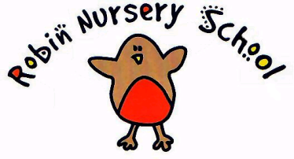
Managing children who are sick, infectious or with allergies

We provide care for healthy children through preventing cross infection of viruses and bacterial infections and promote health through identifying allergies and preventing contact with allergenic substances.

- If children complain of being unwell, or appear unwell during the day ie have a temperature, sickness, diarrhoea or pains, particularly in the head or stomach – the manager or other staff member with the managers consent calls the parents and asks them to collect their child, or send a known carer to collect the child on their behalf.

- The child’s temperature is taken using a forehead thermometer kept in the first aid box. If the child’s temperature is raised, an attempt to cool them down is made by removing top clothing and sponging their head with cool water.

- In extreme cases of emergency, the child should be taken to the nearest hospital and the parent informed.

- The nursery can refuse admittance to children who have a temperature,contagious infection or disease or appear unwell.

- After a bout of diarrhoea and/or sickness, parents must keep children at home for 48 hours after the last episode of sickness/diarrhoea.

- The child will be informed when someone is coming to collect them.

- In the unlikely event of us being unable to notify anyone on the child’s contact list and their health is causing us concern, we will, if we feel it necessary, seek medical advice.

- The setting has a list of excludable diseases and current exclusion times on the main notice board.

Staff are reminded to follow Health and Hygiene Procedures at all times.

Procedures for children with allergies

- When parents start their children at Robin Nursery they are asked if their child suffers from any known allergies. This is recorded on the child’s registration form.

- If a child has an allergy, a risk assessment form is completed to detail the following-

- The allergen - ie the substance that the child is allergic to.
- The nature of the allergic reaction – ie anaphylactic shock, swelling, rash, breathing problems
- What to do in case of allergic reaction, any medication and how it is to be used
- Control measures – such as how the child can be prevented from contact with the allergen
- Review

- This form is kept in with the child’s registration form and details are displayed where staff can see them.
- Generally no nuts or nut products are used within the setting.
- Parents train staff on how to administer special medication in the event of an allergic reaction * Check insurance* - insurance may say that staff must be professionally trained to administer epi pens
Robin Nursery will also need a letter from the child’s GP or specialist stating the child’s condition and detailing the medication to be administered.

- There will always be at least two first aid trained members of staff on duty at all times in the setting.

This policy was adopted at a meeting of The Robin Nursery Committee

Held on ………………………………

Signed on behalf of the Nursery ………………………………………

Name of signatory …………………………………………….. (Chairperson)

