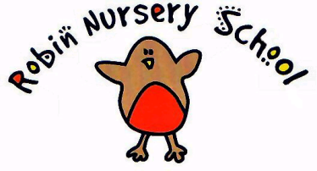
SMOKING & VAPING POLICY

We comply with health and safety regulations and the Welfare Requirements of the EYFS in making our setting a no-smoking/vaping environment - both indoor and outdoor.

Procedure

- All staff, parents and volunteers are made aware of our no smoking policy, this includes vaping

- We display no smoking signs

- Staff who smoke or vape do not do so during working hours - unless on a break and off the premises and not in nursery uniform.

- Staff who smoke during their break make every effort to reduce the effect of the odor and lingering effects of passive smoking for children and colleagues

Legal Framework

The Smoke Free (Premises and Enforcement) Regulations 2006
The Smoke Free (Signs) Regulations 2007

Signed on behalf of the Nursery- Teresa Cutler (Manager)
Signed Jane Follett- (Robin Nursery Chairperson)

Date - 8th October 2020

